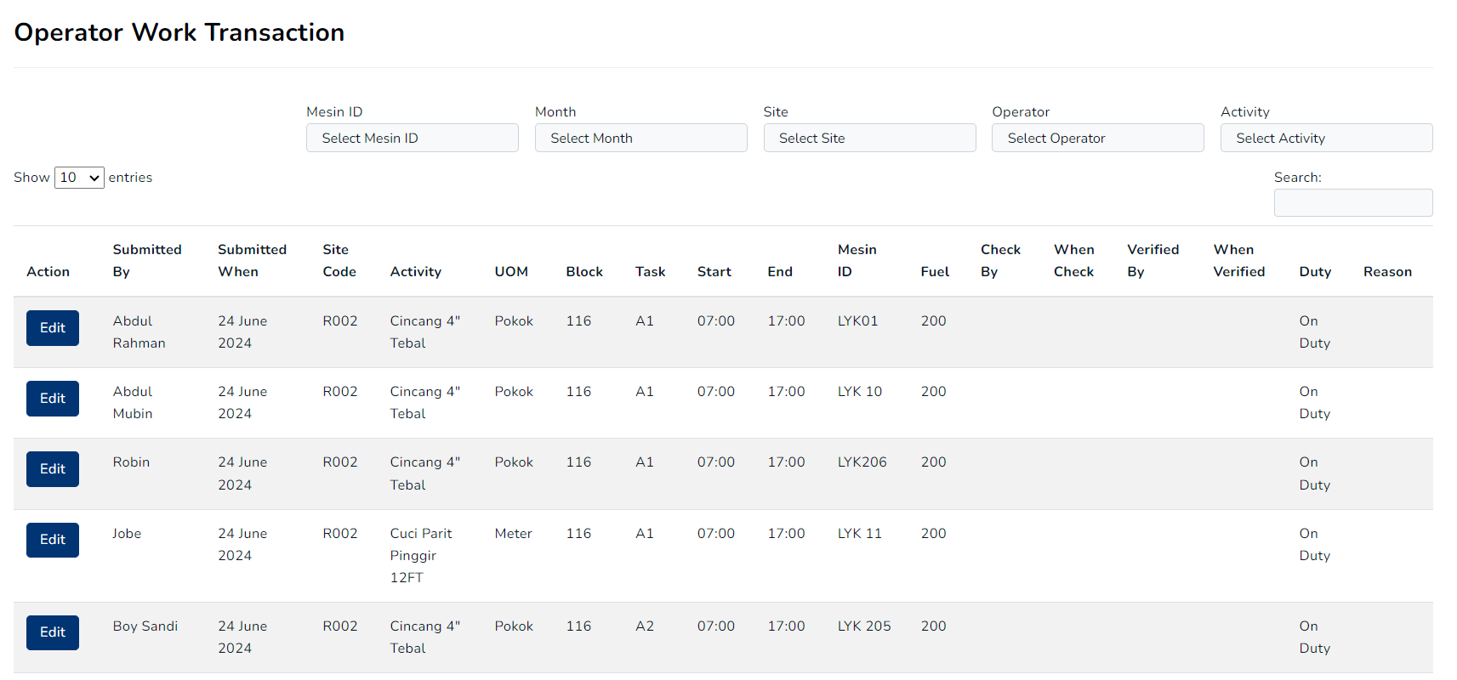

Task :

Make filter like example above (MESIN ID, SITE, MONTH etc) works auto instan load on datatable. (not using submit when filtering and not using datatable filtering feature)

DATA can dummy whatever you want. Point is how filter data works on that condition.  
  
When done sent us github link of source code